
PREBOARD -1 (2022-23)
SET-1 (ANSWERSCHEME)
Subject: GEOGRAPHY  Grade: XII |  | Max. Marks: 70  Time: 3 Hours
SECTION A
There are 17 questions in this section. All are mandatory.
1 | (a) Marxian Theory | 1
2 | (b) Griffith Taylor | 1
3 | (b) high fertility and high mortality | 1
4. | (d) Syria | 1
5 | (a) Both A and R are true and R is the correct explanation of A. | 1

6 | a) i, ii, iii, iv |  | 1
7 |  | (c) Basic industries | 1
8 |  | (d) The North Atlantic Ocean | 1
9 |  | (b) iv, iii, ii, i | 1
10 |  | (A) Both A and R are true and R is the correct explanation of A. | 1
11. |  | a) Tamil nadu | 1
12. |  | (d) Assam | 1
13. |  | a) i | 1
14 |  | c) mega city | 1
 |  | Read the following case study and answer question no 15 to 17.
15 |  | d) All of the Above | 1
16 |  | C) Bhubaneswar | 1
17 |  | (A) provide core infrastructure | 1

SECTION B
Question numbers 18-23 are SA type questions. Question 18 & 19 are Source based questions.
18. Study the map and answer the following questions:
18.a | Cities accommodating population size between one to five million are called metropolitan cities and more than five million are mega cities |  | 1
18.b | City that has got the largest urban agglomeration- Greater Mumbai |  | 1
18.c | The two metropolitan cities in Uttar Pradesh that are ancient towns- Varanasi and Allahabad |  | 1
19. | Observe the given map and answer the following questions:
19.1 | Identify the railway line shown in the map -Trans Canadian Railways |  | 1
19.2 | Name the station marked on the map –A and B – Vancouver to Halifax |  | 1
19.3 | What are the main exports on this route – Meat and wheat |  | 1
20 | The three components of population change are:  1.Crude Birth Rate (CBR): It is expressed as number of live births in a year per thousand of population in a particular region.  2.Crude Death Rate (CDR): It is the number of deaths in a place per thousand of population in a particular region. CBR and CDR are natural factors of population growth. They result in natural population growth, which is equal to the difference between CBR and CDR.  3.Migration: It is the induced factor in population growth. It is the number of people moving in and out of a place due to various social, economic and political reasons. It is taken into account while calculating actual growth of population. |  | 3
21.a | Advantages: (any 2+1)  It can be taken through any terrain.  The initial cost is high but the maintenance cost is low.  It is eco friendly as it requires no fuel.  Disadvanges:  Solids cannot be transported.  Any undetected leakage leads to wastage. |  | 3
 | OR
21.b | WTO is the only international organisation dealing with the global rules of trade between nations.  It sets the rules for the global trading system and resolves disputes between its member nations.  WTO also covers trade in services, such as telecommunication and banking, and others issues such as intellectual rights.
22. | The over-use of ground water resources has led to decline in ground water table in these states.  Over withdrawals in some states like Rajasthan, and Maharashtra has increased fluoride concentration in ground-water, and this practice has led to increase in concentration of arsenic in parts of West Bengal and Bihar. |  | 3
23. | Bioenergy is a potential source of energy conversion. It can be converted into electrical energy, heat energy or gas for cooking. It will also process the waste and garbage and produce energy. This will improve economic life of rural areas in developing countries, reduce environmental pollution, enhance self-reliance and reduce pressure on fuel wood.  One such project converting municipal waste into energy is Okhla in Delhi. (any two advantages) |  | 2+1
SECTION C
Question numbers 24 to 28 are Long Answer based questions.
24. | Human Development Index measures attainments in human development. It reflects what has been attained in key areas of human development like education, health and standard of living. Its value lies between 0 and 1, 0 shows the lowest level of human.  Income approach, welfare approach, basic needs approach and capability approach are the approaches to human development.  Some of the important approaches of looking at human development are:  (a) Income Approach: This is one of the oldest approaches to human development. Human development is seen as being linked to income. The idea is that the level of income reflects the level of freedom an individual enjoys. Higher the level of income, the higher is the level of human development.  (b) Welfare Approach: This approach looks at human beings as beneficiaries or targets of all development activities. The approach argues for higher government expenditure on education, health, social secondary and amenities. People are not participants in development but only passive recipients. The government is responsible for increasing levels of human development by maximising expenditure on welfare.  (c) Basic Needs Approach: This approach was initially proposed by the International Labour Organisation (ILO). Six basic needs i.e How is the use of plastic bags harmful for environmental degradation? Evaluate it by citing suitable reasons.  health, education, food, water supply, sanitation, and housing were identified. The question of human choices is ignored and the emphasis is on the provision of basic needs of defined sections.  d) Capability Approach: This approach is associated with Prof. Amartya Sen. Building human capabilities in the areas of health, education and access to resources is the key to increasing human development. |  | 1+4
25.a | a) i)Agro based Industries:  Agro processing involves the processing of raw materials from the field and the farm into finished products for rural and urban markets. Major agro-processing industries are food processing, sugar, pickles, fruits juices, beverages (tea, coffee and cocoa), spices and oils fats and textiles (cotton, jute, silk), rubber, etc.  ii)Food and Agro processing includes canning, producing cream, fruit processing and confectionary. While some preserving techniques, such as drying, fermenting and pickling, have been known since ancient times, these had limited applications to cater to the pre-industrial Revolution demands.  (b) Mineral based Industries:  These industries use minerals as a raw material. Some industries use ferrous metallic minerals which contain ferrous (iron), such as iron and steel industries but some use non-ferrous metallic minerals, such as aluminium, copper and jewellery industries. Many industries use non-metallic minerals such as cement and pottery industries. |  | 2+3
  Small Scale industry | Large Scale industry
  (i) Its manufacturing place (workshop) is outside the home/cottage of the producer | (i) Large scale industry is totally market oriented industry, involving large scale production and technological advanced methods of production of goods in large factory set up.
  (ii) It uses local raw material, simple power-driven machines and skilled labour. | (ii) It involves a large market, various raw materials, enormous energy, specialized workers, advanced technology, assembly-
 | OR
25.b | Although Africa has natural resources in abundance in terms of its land resources, its forest and water resources, its mineral and energy resources, the most important component to transfer these into usable form- the human resource, is not well developed. The following discussion would make it amply clear why Africa remains industrially backward.  - Specialization of skills/methods of production: African industries still use primitive methods of production, which makes its yield low. Lack of adequate training and opportunities forces most of the African state to have low skilled human capital and most of the workforce remains to be unskilled.  - Mechanization and Technological innovation: Low level of mechanization leads to a cut in the production level and as the industries in Africa are generally not connected with the other competing industries in the world, sharing of technology does not take place in a greater scale .  - Organizational structure and stratification: A high level of organization and an efficient division of labour is essential for the thriving of giant enterprises.  - Access to market and raw material: For basic industries, it is important that the raw materials are easily accessible to the factories of production, and the finished goods should find easy access to markets. This however, lacks because of the lack of good transport network, effective communication facilities and international markets.  - Access to labour supply: Although Africa is quite populous and blue collar workers are available aplenty, skilled labour is in a shortage, which makes industries suffer further on managerial and technological fronts.  - Government policy: Because of the political turmoil that go on in most of the African nations, a long term and healthy government policy towards the progress of industries is absent, thus making it a push factor for foreign multinationals to invest in the said areas.  - Transportation facilities: Development of modem industries requires well transport linkage, so that agglomeration economies can be created. Africa lacks development of adequate network of highways, railways and airway linkage. (any 5 points)
26.a | - Density of population ranges from as low as 13 persons per sq km in Arunachal Pradesh to 9,340 persons in the National Capital Territory of Delhi.  - Among the northern Indian States, West Bengal (903), Bihar (880) and Uttar Pradesh (690) have higher densities, while Kerala (819) and Tamil Nadu (480) have higher densities among the peninsular Indian states.  - States like Assam, Gujarat, Andhra Pradesh, Haryana, Jharkhand, and Orissa have moderate densities.  - The hill states of the Himalayan region and North eastern states of  India (excluding Assam) have relatively low densities  - The Union Territories (excluding Andaman and Nicobar islands) have very high densities of population. |  | 5
 | OR
26.b | The National Youth Policy of Government of India was launched in 2003.  i)It stresses on an all round improvement of the youth and adolescents.  ii)It enables them to shoulder responsibility towards constructive development of the country.  iii)It also aims at reinforcing the qualities of patriotism and responsible citizenship.  iv)The thrust of this policy is youth empowerment in terms of their effective participation in decision making and carrying the responsibility of an able leader.  V)Special emphasis was given in empowering women and girl child to bring parity in the male-female status.  vi)Moreover, deliberate efforts were made to look into youth health, sports and recreation, creativity and awareness about new innovations in the spheres of science and technology
27 | ● Dependence on Erratic Monsoon- Irrigation covers only about 33 per cent of the cultivated area in India. Poor performance of south-west monsoon also adversely affects the supply of canal water for irrigation.  ● Low productivity- The yield of the crops in the country is low in comparison to the international level. Per hectare output of most of the crops such as rice, wheat, cotton and oilseeds in India is much lower. Because of the very high pressure on the land resources, the labour productivity in Indian agriculture is also very low in comparison to international level.  ● Constraints of Financial Resources and Indebtedness -The inputs of modern agriculture are very expensive. This resource intensive approach has become unmanageable for marginal and small farmers as they have very meagre or no savings to invest in agriculture.  ● Lack of Land Reforms- Indian peasantry had been exploited for a long time as there had been unequal distribution of land .After Independence, land reforms were accorded priority, but these reforms were not implemented effectively due to lack of strong political will. Most of the state governments avoided taking politically tough decisions which went against strong political lobbies of landlords. Lack of implementation of land reforms has resulted in continuation of iniquitous distribution of cultivable land which is detrimental to agricultural development.  ● Vast Underemployment- There is a massive underemployment in the agricultural sector in India, particularly in the unirrigated tracts. In these areas, there is seasonal unemployment ranging from 4 to 8 months. |  | 5.
28 | India's railway network is one of the largest in the world. It is a cheap source of fares for travelers in India. The total railway network of India is about 63221 km.  Following are the importance of Indian Railways:  - Indian Railways is the main means of transport for millions of Indians because it makes long-distance travel very cheap and it is a safer journey than other transport.  - It is best suited for carrying heavy cargo over long distances at an affordable cost.  - Indian Railways carries about 80% of the long-distance heavy cargo.  - The railway is also a medium to unite a diverse country like India. |  | 2+3
 | SECTION - D  MAP QUESTIONS  SECTION D Question numbers 29 & 30 are Map based questions having 5 sub-parts each  On the given political map of the world, the following seven features are shown. Identify any five of these features and write their correct names on the lines marked near each feature. |  | 5
A | A major international airport in North America - Chicago
B | A Seaport in Europe – North Cape
C | A major port in South Africa – Cape Town
D | Trans Continental Railways in Russia – St. Petersburg to Vladivostok
E | Major International airport in East Asia -Tokyo
F | An inland water way – Suez Canal
30 | On the given political map of India, locate and label any five of the following with appropriate symbols : |  | 5
a)State with higher level of population density (2011) ( Bihar)
b) Iron ore mines located in Southern most part of Chhattisgarh (Bailadila)
c) Oil Refinery located in Uttar Pradesh.(Mathura)
d) The largest Lignite coal mines.(Neyveli)
e) Southern Metropolitan city connected by Golden Quadrilateral. (Chennai)
f) Oldest Copper mines of Rajasthan (Khetri)
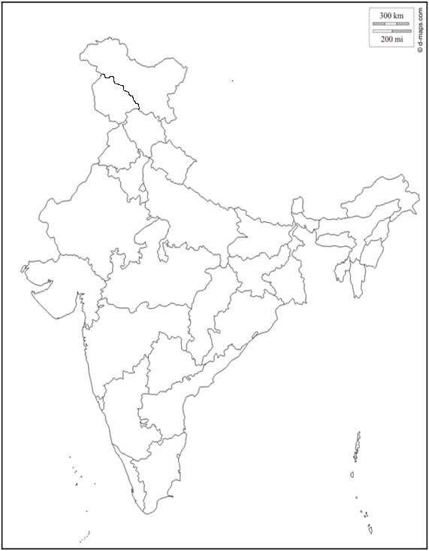
ROLL NO:

